**Project 100011:** [Map your mind](https://intranet.alxswe.com/projects/100011)

Presented by **Yassir BOUKHIMA**

________________________

**FLOW CHART**

**FUNCTION: reads in three numbers and writes them all in sorted order**

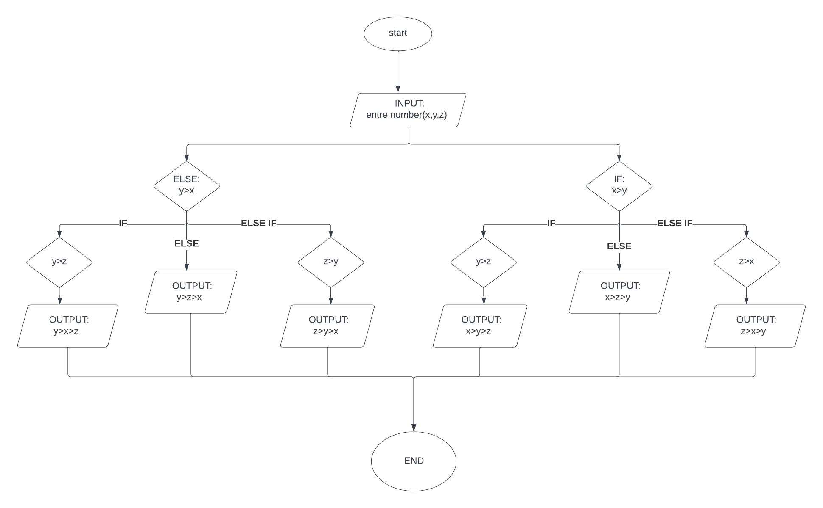

PSEUDOCODE

* START
* INPUT: “entre number (x,y,z)”
* IF x>y
  + IF y>z
    - OUTPUT: print(“x>y>z‘)
  + ELSE IF: z>x
    - OUTPUT: print(“z>x>y”)
  + ELSE
    - OUTPUT: print(“x>z>y”)
  + END IF
* ELSE
  + IF x>z
    - OUTPUT: print(“y>x>z”)
  + ELSE IF
    - OUTPUT: print(“z>y>x”)
  + ELSE
    - OUTPUT: print(“y>z>x”)
  + END IF
* END

code python(option)

print("enter x")

x = input()

print("enter y")

y = input()

print("enter z")

z = input()

if (x > y):

if (y > z):

print("{}>{}>{}".format(x, y, z))

elif (z > x):

print("{}>{}>{}".format(z, x, y))

else:

print("{}>{}>{}".format(x, z, y))

else:

if (x > z):

print("{}>{}>{}".format(y, x, z))

elif (z > y):

print("{}>{}>{}".format(z, y, x))

else:

print("{}>{}>{}".format(y, z, x))